Charting the Future – AI Innovation Quest (working title)
Project Overview
The proposed app will be a gamified “Pocket Companion” for the client’s AI learning journey, providing employees with an engaging way to track and participate in AI-related learning activities, practical challenges and innovation opportunities.
The experience will build on proven game mechanics from previous Talent Voyage project while establishing a distinct identity and user experience. Participants explore an expanding space-based world, travel between planets and stations, complete AI missions, apply learning to their work, share knowledge with colleagues and earn recognition through points, levels and badges.
Theme and Experience Concept
The experience is framed as a visit to a possible future in which the client connects communities across Earth and beyond (note-the client’s industry is shipping). Participants’ mission is to explore, experiment and gather ideas that can help shape the client’s journey toward that future. The science-fiction setting provides a playful narrative layer around real, present-day AI learning and experimentation; the challenges themselves remain practical and directly connected to participants’ work.
Participants begin at Mission Control, the central home base, and navigate an illustrated star system in a small spacecraft. New planets, stations and destinations are revealed in recurring 3–4 month cycles. Each cycle will contain a mix of Learn, Practice, Share and Transform challenges at different levels of difficulty, so the world does not imply that all employees are starting at the same level of AI capability.
A participant’s spacecraft represents them on the map. In an enhanced version of the experience, the ship could be customized with selected colours, markings or team identity, while its cockpit becomes a persistent personal space that accumulates badges, artifacts and other visual evidence of progress.
An AI/bot copilot can act as a recurring guide: introducing destinations and missions, explaining requirements, sharing notifications and celebrating achievements. This is envisioned as a character/avatar with scripted content rather than an LLM-enabled chatbot; genuine conversational AI could be explored separately if desired.
Purpose and Objectives
The app is intended to create a visible, shared journey toward responsible and practical AI adoption across the client organization. Specifically, it will:
- Encourage responsible experimentation by giving employees structured opportunities to try AI tools and approaches in meaningful workplace contexts.
- Build practical AI skills through a combination of learning, application, knowledge sharing and innovation activities.
- Support an organization-wide conversation about AI, creating opportunities for employees to exchange ideas, new potential tools, prompts, experiences and lessons learned.
- Make progress visible by providing employees and program administrators with a shared way to track participation, achievements and progression, encouraging friendly competition through leaderboards and real-world rewards.
- Recognize contribution and experimentation, not simply course completion, through points, levels, badges and other forms of recognition.
- Sustain engagement over time by allowing the experience to evolve as new learning resources, technologies and business applications emerge.
Recommended structure
We recommend that Charting the Future be designed as an evolving framework rather than a fixed curriculum, since the client anticipates maintaining the Pocket Companion for at least two years, and since new challenges will be added later and others will be periodically renewed (i.e., reading the newsletter, attending upcoming webinars, participating in a case competition).
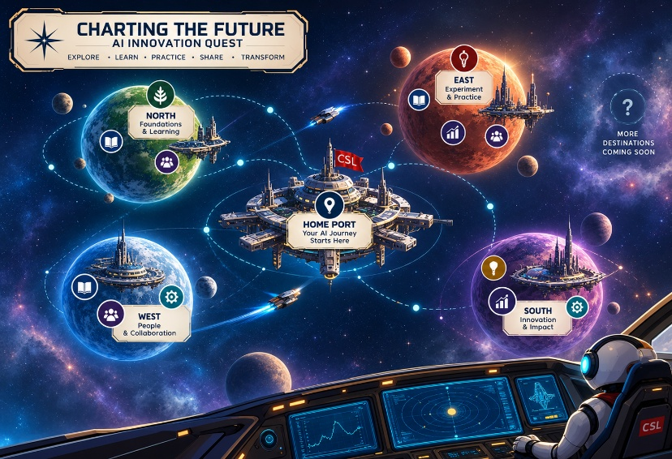
- Periodic world building and map expansion: We propose that the illustrated star map expands in three-month cycles, with each new phase revealing a new region, destinations and AI learning opportunities for the entire organization. The new regions would be visible and explorable by all participants when released, creating a shared sense of progress and encouraging curiosity about what comes next.
Figure 1 AI-generated concept of expanding map.
- Challenges unlock based on readiness. While the star map is visible to all, access to individual challenges may be tied to the participant meeting defined readiness criteria; for example, completion of prerequisite learning or challenges, achievement of a particular level or badge, or other requirements established by the program team.
- Progress remains individual. Participants don't lose access to earlier regions and can return to unfinished or repeatable challenges. Faster participants have more activities available; slower participants aren't prevented from seeing where the organization is going.
- Seasonal game mechanics reward progress and keep learning journey fresh. We recommend competitive cycles approximately every 3-4 months, restarting shortly afterwards with a new region and fresh challenges.
  - At the end of the cycle, participants’ points and leaderboard positions reset to zero, though they keep the levels and badges earned. A new cycle then begins with a newly revealed region of the map and fresh challenges to explore.
  - This gives everyone a renewed opportunity to compete, while preserving recognition of longer-term progress and maintaining momentum throughout the learning journey.
This approach allows the client to build the AI journey progressively. New learning resources, challenges and applications do not need to be fully defined at launch; they can be developed and added as the client's AI capabilities and priorities evolve.
Core Requirements
The initial platform would be designed around several core capabilities.
Evolving learning journey.
- Participants navigate an illustrated space map that grows over time. New planets, moons or stations are introduced as the client releases new learning opportunities and challenges, while previously discovered destinations remain accessible.
- Future destinations initially appear at the edges of the star map as faint luminescence, silhouettes or question marks and are revealed through a brief "new destination discovered" experience when released.
- Periodic leaderboard seasons create fresh opportunities for recognition without erasing lifetime progression. Top users are recognized and rewarded on a 3-4 month cycle, after which leaderboards are reset. Seasonal achievements earn in-game assets (special badges or items) or real-world rewards.
Configurable challenges
- Administrators can create and update challenges, assign point values, establish prerequisites and determine how completion is validated.
- This needs to support the range already envisioned by the client, from entering codes found in newsletters or learning sessions to submitting prompts, reflections, screenshots, links or evidence for administrator review.
- The requirements and point value of each challenge, whether fixed or variable, will be displayed in the pop-up card for that challenge on initial participant view.
Challenges and User Experience
- The challenge system needs to support varied activities, validation methods and point values. Tasks are categorized as Learn – Practice – Share – Transform, with participants encouraged to focus on “share” and “transform” tasks more as they move up in rank.
- Illustrative examples include:
- Learn: Read the client’s monthly AI newsletter and enter a hidden code; attend a Lunch & Learn or webinar; complete assigned AI training; review an approved guide or resource.
- Practice: Complete a prompt-engineering mission using the CREATE framework; test an approved AI tool on a real work task; save and submit a reusable prompt; participate in an AI scavenger hunt or case competition.
- Share: Help a colleague use an AI tool; share a useful prompt, tip, story or use case; contribute a prompt to a company-wide library; present an example at a Lunch & Learn or for the newsletter.
- Transform: Identify and submit an AI-enabled business or process improvement idea; prototype a new way of working; create an AI agent for individual use, subject to appropriate IT review before broader sharing.
- Completion of challenges may be validated through hidden codes, links, short reflections or summaries, screenshots or other evidence, automated rules where practical, or administrator review. Some challenges may be repeatable or renewed each cycle (i.e., read the monthly newsletter).
- Progression and recognition. Participants accumulate points and progress through defined ranks including Beginner, Explorer, Navigator and Innovator.
- Personal journey and identity. Each participant has a profile and personalized ship/avatar that travels through the experience. Special badges or in-game items may be rewarded to recognize specific behaviours and accomplishments. Their completed challenges, achievements, reflections and recognition create a persistent record of their AI journey.
- Leaderboards and shared progress. Individual and potentially team-based views provide visibility into participation and create an element of friendly competition.
  - Leaderboards should be designed to encourage continued participation rather than make the experience feel inaccessible to employees who join later or progress at different speeds.
  - One possible mechanism is to offer a “zoomed in” view of the leaderboard where participants can view the 10 people immediately surrounding themselves and see how they progress against those close peers.
- Administration and reporting. Program administrators can manage participants, challenges, points and recognition; add new content over time; communicate with participants via email and in-game broadcasts; and generate reports on participation and progress.
- Separate and secure program environment. The application can reuse proven Talent Voyage design and functionality while operating on its own backend and data environment, keeping participant information, reporting and future development separate from the existing program.
Additional / Optional Features
The following ideas can add interest and engagement to the tool. Some need to be determined at the outset of the project, while other features may be added later.
- Mission Control. A persistent central space station acts as the participant's home base, providing access to key functions such as instructions, mission discovery, leaderboards, customization and community features. Distinct areas within Mission Control could include the Mission Board for challenges and progress, the Commons for conversation and sharing, and the Hangar for ship/team customization.
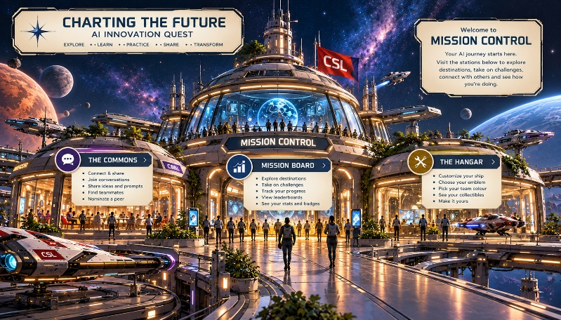
- Customizable ships. Participants personalize their spacecraft through a curated selection of colours, markings, and team emblems, creating individuality without compromising the client's visual identity.
Figure 2 AI-generated concept of Mission Control
- The Commons. A social area supports topic-based conversations such as prompt recommendations, AI tools, useful applications and questions. Peer recognition or nomination activities could also live here, as could team formation mechanics.
- AI Copilot. Participants could choose from a small set of visually distinct bot copilots with different personalities. The copilot appears in the cockpit and mission briefings to provide scripted guidance, notifications, encouragement and celebration. It is not intended to function as a live AI chatbot in the initial version.
- Teams. Employees form small, voluntary teams of 5-7 players for friendly competition, peer support or selected collaborative activities. Teams do not need to be tied to departments or working groups and would be separate from overall leaderboard ranking. Team profiles and flags could reinforce community. A separate Team Leaderboard could be made available to compare progress within the team, among peers.
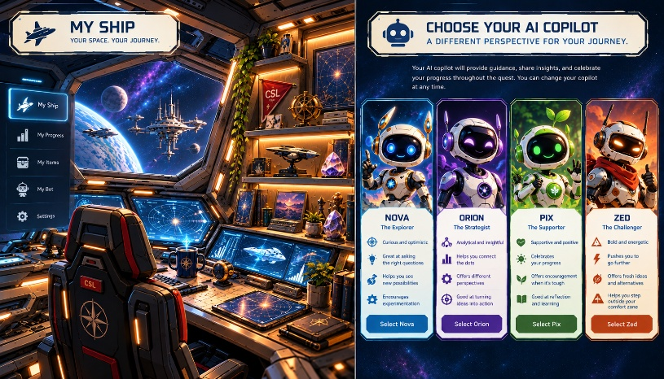
- Personal cockpit and collectibles. The participant’s cockpit or bridge becomes a visual record of their journey. Badges, rank items, team flags, seasonal souvenirs and selected challenge artifacts can gradually appear in the environment as participation grows, giving the ship a sense of history without requiring every completed challenge to generate a unique asset.
Figure 3 AI-generated image of Cockpit and Bot Copilot
- Personal Trunk. A visual collection of the participant's journey could accumulate badges, rank items, team flags, completed-challenge "books," messages and other artifacts as participation grows. Rank items could include compass for the Explorer rank, spyglass for Navigators and a sextant for those achieving Innovator status.
- Seasons. Periodic leaderboard seasons could create fresh opportunities for recognition without erasing lifetime progression. Seasonal achievements could connect to in-game assets (special badges or items) or real-world rewards.
- Progressive map discovery. New destinations could initially appear as silhouettes or unexplored waters and be revealed through a brief "new land spotted" experience when released or unlocked.
Estimated Timeline and Milestones
The original concept assumed an approximately 3–4 week initial development cycle using the existing Talent Voyage foundation. The final schedule will be validated once the delivery approach, core versus enhanced feature set, and development responsibilities are confirmed:
Timing | Milestone | Key Activities
Week 1 | Define and Design | Confirm experience concept, program structure, progression/points logic, initial challenges, team/leaderboard approach and visual direction. Establish separate technical environment and adapt Talent Voyage foundation for this expanded Pocket Companion tool.
Week 2 | Build Core Experience | Confirm experience concept, program structure, progression/points logic, initial challenges, team/leaderboard approach, visual direction and core versus enhanced scope. Confirm technical architecture and determine what, if anything, should be reused from the Talent Voyage foundation.
Week 3 | Populate and Extend | Configure initial destinations and challenges; implement leaderboards/teams and selected community or recognition features; build reporting and communications functions.
Week 4 | Test and Launch | Participant/admin testing, mobile and browser QA, permissions and data testing, content refinement, administrator orientation, pilot adjustments and launch preparation.
Ongoing | Expand the Voyage | Release new destinations and challenges, introduce new recognition opportunities, review engagement data and progressively activate optional features as THE CLIENT's AI journey evolves.

